2.2 Planning Proposal - 12-20 Shiralee Road
RECORD NUMBER: 2023/791
AUTHOR: Craig Mortell, Senior Planner

EXECUTIVE SUMMARY
Council is in receipt of a Planning Proposal and associated letter of offer to enter into a (voluntary) planning agreement in respect of land at 12-20 Shiralee Road, known as the Hilltop Park area. The proposal seeks to rezone part of the RE1 Public Recreation zone land and adjust the minimum lot size map to enable approximately 50 additional residential lots.
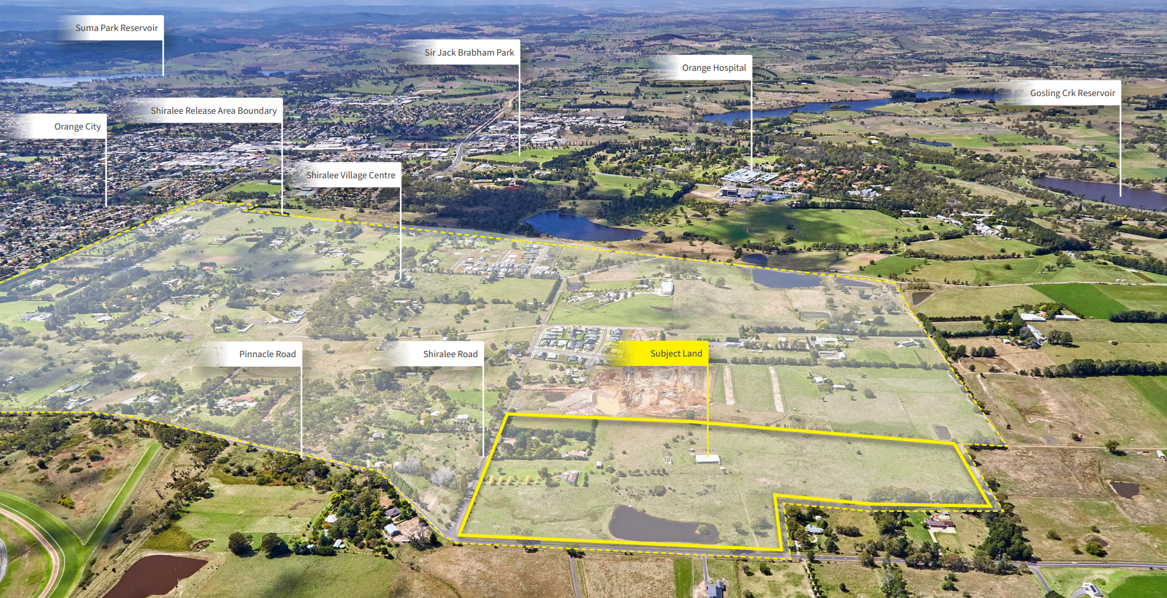
The Shiralee master plan has zoned extensive areas of privately owned land as RE1 Public Open Space. Due to the State Government’s developer contributions cap of $20,000 per lot, the ability to fund acquisition of this land through contributions is very much limited.
The RE1 land on the subject site would reduce from 7.39 ha to 4.67 ha. Together with an adjustment to the minimum lot size map on the larger lot areas of the site this would enable the additional 50 lots. In exchange the proponent is offering, under a (voluntary) Planning Agreement (VPA), to forego any compensation for the open space land, build and embellish the remaining RE1 land “Hilltop Park” to a value of approximately $2.3 million dollars and dedicate the park to Council at no cost.
The offer includes the first 2 years of maintenance post development. The VPA recognises that a quality park will add value to the residential subdivision of the overall site as well as provide a valuable passive recreation asset for the amenity of the whole community.
Alternatively, Council would need to acquire the full 7.39ha of RE1 land, as currently zoned as a part of a future subdivision. Additional embellishment of the park would be dependent upon future Council budget allocations. The potential additional 50 residential lots would also be foregone.
The conceptual vision/design of the reduced park area has been reviewed and is considered to provide a quality outcome that can host a reasonable number of visitors and passive recreation opportunities. Generous open space linkages are maintained for the community and Pinnacle Road interface remains a scenic rural edge with both parkland and landscaping on larger private lots.
In recent times, Council has entered into 3-4 other agreements in the Shiralee Estate using the VPA process to reduce the financial burden of securing community open space by allowing developers some increase in allotment density/yield and in some cases, a variation to current land use zones. This proposal will provide Council with its largest developed open space are in that suburb.
Given the State Government restriction on the amount of developer contributions that can be collected which pay for all matter of public provisions, including the open space, this negotiated approach to land development is essential in obtaining anywhere near the scale of open space that was originally planned for Shiralee without adversely impacting on Council’s financial position.
It is considered that this planning proposal and associated planning agreement will benefit all parties into the future.

LINK TO DELIVERY/OPERATIONAL PLAN
The recommendation in this report relates to the Delivery/Operational Plan strategy “7.1. Engage with the community to develop plans for growth and development that value the local environment”.

FINANCIAL IMPLICATIONS
The contribution plan for Shiralee has limited ability to ability to fund open space acquisitions identified in the master plan. This Planning Proposal includes an offer to enter into a (voluntary) Planning Agreement with respect to the provision and embellishment of public open space.

POLICY AND GOVERNANCE IMPLICATIONS
Nil

Recommendation
- That Council resolve to support the Planning Proposal subject to:
  - adjusting the proposed minimum lot size for R2 land fronting Pinnacle Road from 1000m² to 2500m² and
  - nominating the 40 additional lots park fringe lots within the site as a “buffer area” for the purposes of clause 1.19(1)(e) of State Environmental Planning Policy (Exempt and Complying Development Codes) 2008.
The intent of (b) being to ensure development of the additional lots is excluded from Complying Development and require separate Development Applications.
- That Council also support the associated (voluntary) Planning Agreement (VPA) and forward both matters to the Department of Planning and Environment for a Gateway Determination.
- That subject to any conditions of a Gateway Determination staff proceed to undertake agency consultation and public exhibition of both the planning proposal and the VPA and report back to Council.
- That the architectural package in Appendix B serve as the basis for drafting an amendment to the Shiralee DCP for the subject land, and that this DCP amendment be placed on public exhibition alongside the Planning Proposal.

FURTHER CONSIDERATIONS
The recommendation of this report has been assessed against Council’s other key risk categories and the following comments are provided:
Service/Project Delivery | The Planning Proposal could be perceived as establishing a precedent in Shiralee that open space can be exchanged for more residential potential due to the limits of the contribution plan. This could be seen to erode the vision of the Shiralee masterplan for an important residential growth area.
Financial | The Shiralee master plan identifies extensive areas for public open space. Contribution plans for the area are subject to a $20,000 per lot cap which limits the ability of the plan to fund the acquisition of all areas. The Planning Proposal represents an opportunity to address this situation with respect to the Hill Top Park.
Reputation/Political | Planning Proposals within master planned areas need to maintain consistency with the overall vision and objectives of the master plan to maintain community confidence in the planning system.

SUPPORTING INFORMATION
In brief the proposal seeks to
- rezone part of the Site from RE1 Public Recreation to R1 General Residential, and part of the Site from R2 Low Density Residential to R1 General Residential;
- amend the minimum lot size controls for parts of the Site currently zoned R1; and
- apply minimum lot size controls to that part of the Site to be rezoned from RE1 to R1; and
The proposal will enable subdivision of the site for 50 additional residential lots, for a total of approximately 198 residential lots plus 1 super lot (4,989m2). Ultimately the site is anticipated to provide approximately 206 dwellings, and approximately 41,553m² of public open space.
Strategic Planning Framework
The proposal has been reviewed across a range of local and state plans, policies, guidelines and regulations as required by the NSW Department of Planning and Environment’s Local Environmental Plan Making Guideline (September 2022). Under this guideline the proposal would be categorised as a Complex Planning Proposal primarily due to its reliance on a supporting (voluntary) Planning Agreement. This designation is largely and administrative matter and primarily relates to expected timeframes for the processing and assessment of the proposal.

Local Strategic Planning Statement (LSPS)
The LSPS supports new housing in residential release areas, such as Shiralee and seeks to provide diverse housing choices and opportunities to respond to the local demographics and population needs. The LSPS also seeks to ensure that building design and construction is of a high quality and maintains resident amenity. This informs the local housing strategy and drafting of DCP provisions. The overall concept presented in the Planning Proposal is consistent with this intent.

Orange Local Housing Strategy (OLHS)
Chapter 7 of OLHS sets out housing strategy priorities including:
3 Facilitate infill opportunities for housing near jobs and service
Identify suitable areas for increased densities which are strategically located close to or well connected to existing and future services such as commercial and employment centres and transport to make more effective use of existing community infrastructure and facilities.

In this respect the proposal seeks to increase the number of residential lots delivered in Shiralee and would therefore make more effective use of infrastructure and facilities being developed in the Shiralee area generally. The creation of an extra 50 lots is unlikely to have a significant impact on land prices, with any effect being to add a marginal amount of supply and improving availability.

The additional lots along the edge of the park will be subject to specific design requirements illustrated in Appendix B to the proposal. With a need to be designed to address both the street and the park this will diversify the built form. To ensure this outcome it is recommended that Council seek to exclude the 40 “park fringe” lots from State Environmental Planning Policy (Exempt and Complying Development Codes) 2008.

This would result in building on the affected lots requiring a DA rather than a CDC, however this is necessary to ensure the parkland is appropriately addressed and activated by the dwellings rather than a line of blank fences and back walls of sheds. Low open fencing and dwellings looking out onto the park will enhance passive surveillance, security and create a sense of welcome which will encourage utilisation of the parkland.

Shiralee DCP
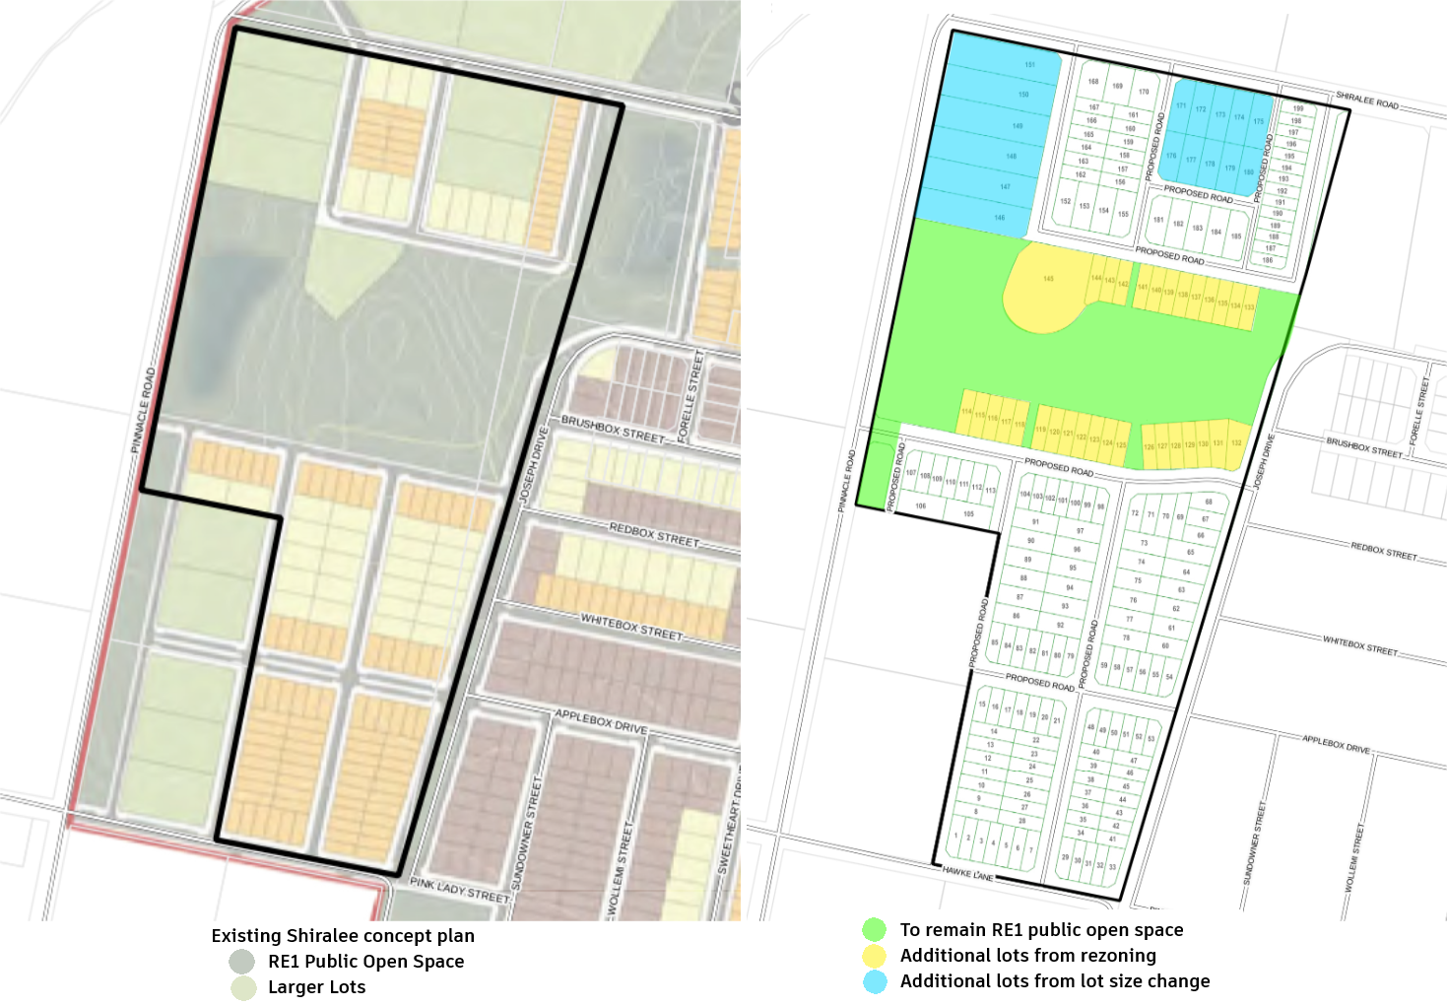
The proposal foreshadows a subdivision design that broadly respects the Shiralee master plan principles by including mixture of lot sizes and locating compact lot sizes closer to open space areas to enable them to “borrow” amenity from the public realm.

The 40 lots created along the northern and southern edges of the open space will be required to address both the street and the park in order to avoid a wall of blank fencing onto the public realm. An architectural package has been included in the planning proposal as Appendix B.
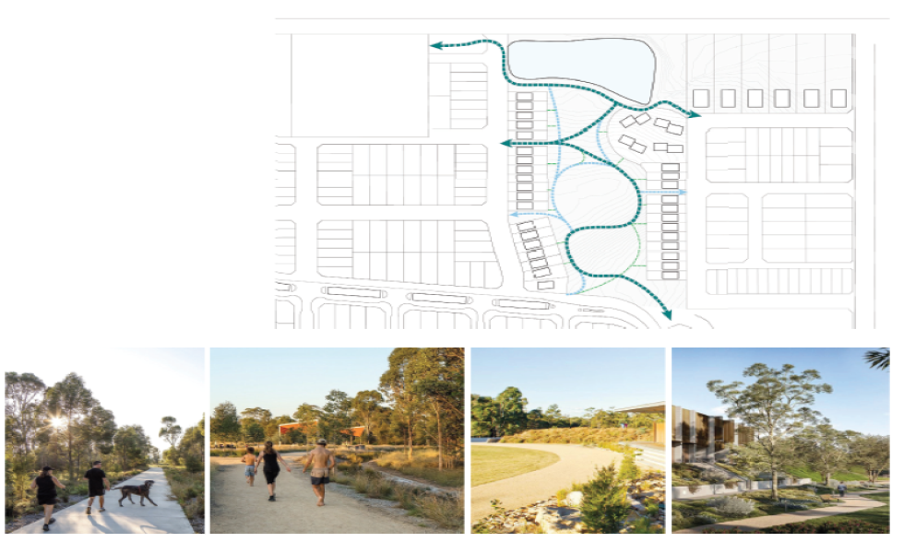
Indicative Park edge treatment.

The architectural package sets out lot typologies for the additional lots in terms of setbacks, fencing treatments, solar access and the like. Combined with the embellishment plan that includes footpaths along the fringe lots which link into the broader design for the park. These matters will be folded into the Shiralee DCP requirements so that future dwellings on these lots will address the park as well as the public road.
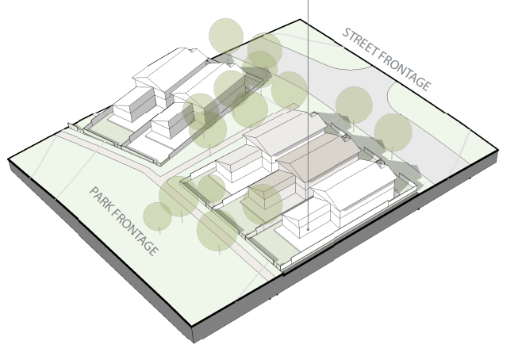
The placement of these lots has been considered to ensure the park has multiple broad connections to public roads. Together with the embellishment plan this will ensure the park remains approachable to all and is not regarded as semi-private for the lots fringing the park.

The road layout remains relatively consistent with the grid-based approach of the master plan, maintaining high level of permeability. Some adjustment to the road layout is shown to ensure road intersections on neighbouring lands are functional.

The proposal replaces 5 larger lots with 15 smaller, but still generous, lots that maintain the ability to keep the built form back from Pinnacle Road – it is anticipated that lots along Pinnacle Road will have building envelopes placed towards the eastern end ensuring that soft landscaping is presented to Pinnacle Road.

Contributions Plan
Currently there is a significant shortage in the contributions plan due to the $20,000 cap. This means the ability to fund acquisition of the extent of public open space envisioned by the Shiralee Plan is constrained. A (voluntary) Planning Agreement (VPA) has been discussed between staff and the developer and is seen as a positive way to address the constraint in the contribution plan as well as deliver a quality public open space for the community. More details on the VPA are provided below.

(Voluntary) Planning Agreement
The (voluntary) Planning Agreement (VPA) broadly consists of the following aspects.
- Council agrees to
  - reduce the extent of public open space on the site
  - support increasing the number of residential lots by 50, and
  - exempt the additional 50 lots from section 7.11 contributions, this equates to $1 million dollars (50 lots x $20,000 cap per lot)
- In exchange the developer
  - foregoes financial compensation for the dedication of the open space.
  - embellish the park by a minimum of $2 million dollars and
  - dedicate the park to Council at no cost.
It should be noted that all other lots on the site would continue to be subject to normal contributions. More details of the VPA are provided in the attached “letter of offer”.

The VPA includes embellishment of the remaining public open space as detailed in the attached letter of offer. The initial concept vision for the park is outlined in the attached documents and represents approximately $2.3 million of works to be provided. Ordinarily Council would be required to purchase public open space. Assuming a conservative rate of $30/m² this would amount to $1,827,390 based on the current extent of public open space (60,913m²). Against this Council would be foregoing $1 million of s7.11 contributions but also receiving a fully embellished and dedicated park and the first 2 years of maintenance at no cost.

Staff have reviewed and negotiated a “Park Plan” with the developer to provide an agreed basis for the extent and standard of works that are to be delivered. This ensures that the park is in line with an appropriate service standard and can be readily maintained once it has been dedicated to Council. Additionally, the developer will be responsible for maintenance for the first 2 years post establishment.
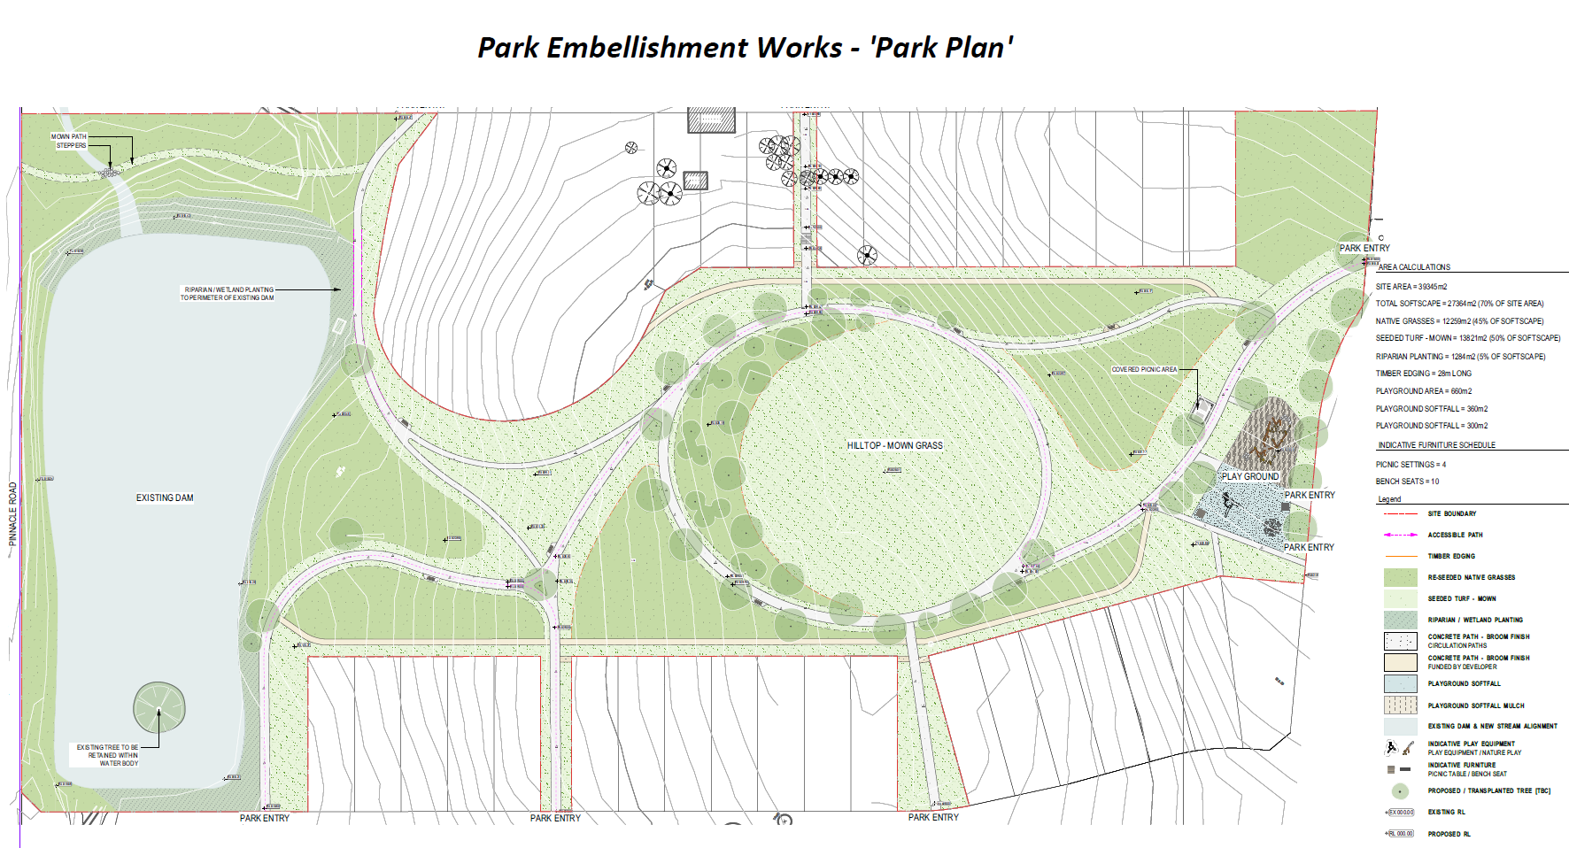

Central West and Orana Regional Plan (CWORP)
The proposal is not inconsistent with the CWORP and has been assessed against relevant directions as follows:

Direction 12 – Plan for greater land-use compatibility.
The proposal incorporates rural edge buffers, primarily along Pinnacle Road. Larger lots northwest of the parkland will be required to have building envelopes positioned toward the eastern end of each lot. This will ensure that the rear of the lots present a soft landscaped aspect and avoids built form (both in terms of dwellings and outbuildings).

Direction 14 – Manage and conserve water resources for the environment.
The proposal retains and incorporates a large spring-fed dam into the park design. This feature and the overflow area to the north will be enhanced with appropriately riparian / wetland plantings. From a stormwater perspective, only a modest area of the site drains towards this feature and will mostly be infiltrate within the parkland before reaching the dam. Notwithstanding this the dam provides a settling opportunity and the riparian / wetland planting will assist with ensuring a high standard of water quality. This will be considered in more detail during a future DA assessment.

Direction 15 – increase resilience to natural hazards and climate change.
Parts of the overall site are subject to flooding and/or inundation from overland stormwater flows. The proposed subdivision design avoids residential lots in these areas. Flooding will be considered in more detail during a future DA assessment. The land is not subject to bushfire hazards and embellishment of the parkland with mature trees and wetland plantings is likely to make a positive contribution towards addressing the urban heat island effect.

Direction 16 – Respect and protect Aboriginal heritage assets.
Section 2.6 of the Planning Proposal document addresses Aboriginal cultural heritage. A search of the Aboriginal Heritage Management System (AHIMS) was undertaken which did not identify any sites or places within 200m of the subject land. This will be considered in more detail during a future DA assessment.

Direction 22 – Manage growth and change in regional cities and strategic and local centres.
The proposal includes architectural concepts and requirements in Appendix B which will form the basis for amending the Shiralee masterplan DCP, which will in turn manage the growth and change proposed. This underscores the need to remove the affected lots from the operation of SEPP (Exempt and Complying Development Codes) to avoid generic complying development forms, particularly on the edges of the parkland.

Direction 25 – Increase housing diversity and choice.
As well as marginally increasing supply by 50 lots the proposal will introduce new building forms and typologies to increase the range and densities available within Shiralee.

Direction 28 – Manage rural residential development.
The proposal seeks to reduce the current 3,800m² Minimum Lot Size (MLS) in relation to large lots in the R2 zone on the northern end of the site. This involves 700m² lots along the Shiralee Road frontage and 2800m² lots along the Pinnacle Road frontage. It should be noted that proposal currently contains mapping indicating 700m² and 1000m² respectively for these areas. An MLS of 1,000m² along Pinnacle Road where the indicative plan shows lots from 2799m² to 2819m² could result in pressure to split these lots in half and that would bring built form closer to the Pinnacle Road frontage.

Accordingly it is recommended that Councils support for the proposal should be contingent upon changing this MLS from 3,800m2 to 2,500m2. This would still allow for some flexibility in lot design and layout without compromising the future protection of the Pinnacle Road interface.

Direction 29 – Deliver healthy built environments and better urban design.
The proposal reduces the extent of public open space however the embellishment of the park and inclusion of a playground area will enhance the built environment and encourage passive recreation use. The image below gives an approximation of how the proposed playground may be delivered. By contrast if Council were to acquire the full extent of the RE1 land such embellishment would be unlikely to occur in the short to medium term and as such the proposal can be seen as making a positive contribution to a healthy built environment.

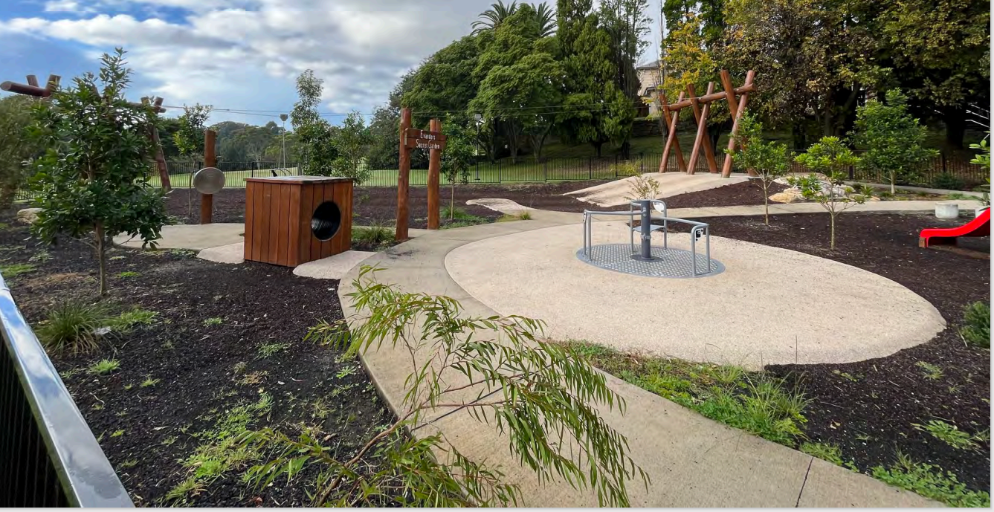

Relevant SEPPs
SEPP (Biodiversity and Conservation) 2021
The SEPP aims to protect the biodiversity values of trees and other vegetation in non-rural areas of the State and preserve the amenity of non-rural areas of the State through the preservation of trees and other vegetation. The SEPP focuses on protecting bushland, trees, heritage items, waterways, wetlands and koalas.

The SEPP is relevant to the Planning Proposal as it affects land in a non-rural zone and will facilitate a development outcome that is likely to result in the clearing of native vegetation with resulting potential impacts in terms of the biodiversity resources of the land.

A Biodiversity Assessment Report (BDAR) has been provided to inform assessment of the proposal and guide future decision making relating to the development of the land for residential and public purposes. A copy of the BDAR is attached as Appendix A to this report.

The BDAR finds that the site is a heavily modified residential and agricultural block, located within a rapidly developing rural residential area. Approximately 0.93ha of the Southern Tableland Creekflat Ribbon Gum Forest Plant Community Type (PCT) was present on the site. This PCT is located primarily to the north and south of the existing dam.
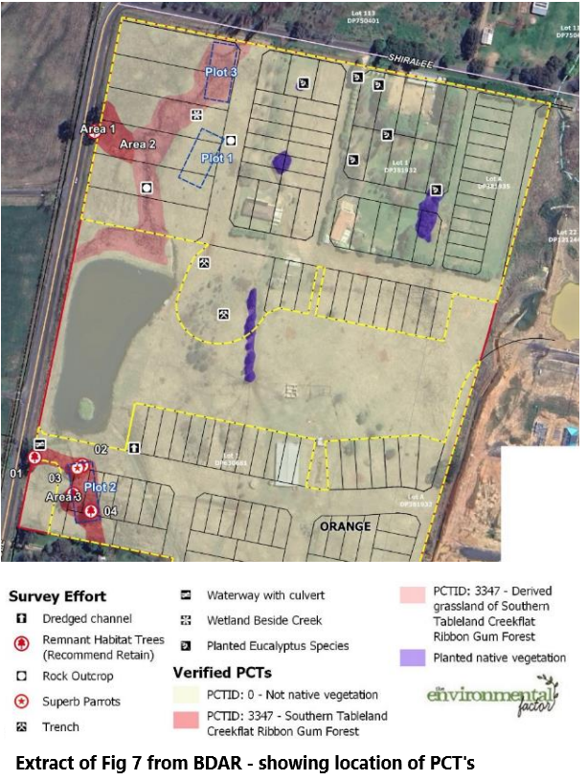
The PCT is not associated with any threatened ecological communities however the Superb Parrot (listed as vulnerable under the BC Act and EPBC Act) was recorded within the PCT during surveys.

The PCT is described as comprising isolated patches on the lower areas of the land and adjacent properties. Remnant areas of the PCT are limited to the drip line of remnant trees and the ground-stratus was predominantly exotic due to historical livestock grazing and overstorey clearing. Derived grassland areas of native tussock cover are present in areas north of the large dam forming a “derived” version of the PCT.

SEPP (Housing) 2021
The SEPP aims to promote the delivery of diverse housing types while meeting the needs of more vulnerable members of the community. The proposal seeks to increase the supply of residential lots by 50 and embellish the local park to a considerable degree. The range in lot sizes on the land will allow for a mix of housing typologies and the increased supply will contribute to reducing pressure on property prices.

SEPP (Resilience and Hazards) 2021
The SEPP requires that Council consider the contamination potential of the land, and if found to be contaminated be satisfied that the land is suitable for development either in the current state or following remediation measures.

The proposal is supported by a Preliminary Site Contamination Assessment prepared by Barnsons. The assessment were completed in order to identify whether contamination is present and to assess the need for possible further investigation, remediation or management. The results of the investigations concluded that the land is largely suitable for residential development. Recommendations have been included with respect to management and disposal of partially demolished buildings near the centre of the site – this will be considered in more detail as part of any DA assessment.

SEPP (Transport and Infrastructure) 2021
The SEPP aims to facilitate the delivery of infrastructure across NSW by providing a consistent framework for infrastructure provision. Schedule 3 of the SEPP defines subdivisions creating 200 or more lots as traffic-generating development triggering a need to refer to the Transport for NSW (TfNSW). The proposal seeks to create 199 residential lots and 1 lot for public open space. The Proponent has recognised that this places the development on the cusp of being traffic-generating development and has no objection to the matter being referred to TfNSW. Referral has not occurred at this time but is anticipated to be a requirement of a gateway determination.

The proposal is supported by a Traffic Impact Assessment (TIA) which has considered:
- existing traffic and parking conditions.
- suitability of parking in terms of supply and layout
- service vehicle requirements
- pedestrian and bicycle requirements
- traffic generating characteristics of the proposal.
- proposed access arrangements.
- impact of the proposal on the surrounding road network.
- the planned vehicle, pedestrian and cycling transport arrangements to the land under the Shiralee DCP Masterplan framework.

The TIA concludes that the proposal could not be expected to compromise the safety or function of the surrounding road network even when significant background growth rates are applied, and the surrounding network has ample spare capacity to accommodate background growth, the proposed development and future traffic associated with the Shiralee DCP Masterplan.

As stated, the matter has not been formally referred to TfNSW under Schedule 3 but it is anticipated that a Gateway Determination is likely to include such referral during the agency consultation phase.

Section 9.1 Ministerial Directions
The Planning Proposal has addressed all section 9.1 Ministerial Directions at page 48, many of which are not applicable to the proposal. The following summarises the relationship of the proposal to the most relevant Directions.

Direction 1.1 Implementation of Regional Plans
This Direction requires proposals to be consistent with the requirements of regional plans. The proposal is considered to be consistent with the CWORP refer to discussion under that heading above.

Direction 1.4 Site Specific Provisions
This Direction requires a proposal for a specific development to contain drawings that show details of the proposed development. The proposal has included conceptual subdivision layouts and is supported by a “Park Plan” to illustrate how Hilltop Park would be established and embellished as a result of the proposal.

Direction 4.1 Flooding
The proposal acknowledges that it is inconsistent with Ministerial Direction 4.1 – Flooding and seeks to justify the inconsistency on the basis that the Planning Proposal is supported by a Flood Risk Impact Assessment by GRC Hydro which supports Councils modelling obtained from the Blackmans Swamp Creek and Ploughmans Creek Floodplain Risk Management Study. GRC Hydro consider the proposed works will meet the objectives of Council’s DCP chapter 4A development controls.

Direction 4.4 Remediation of Contaminated Land
This Direction requires that proposals must not permit a change in the use of land unless it has considered whether the land is contaminated and if so whether the land is suitable for the proposed use, either in its current state or after appropriate remediation has been completed.

A Preliminary Contamination Assessment has been undertaken by Barnsons which generally found that the land is suitable for the proposed development. Recommendations were included for the management and disposal of partially demolished buildings near the centre of the site. These matters would be considered in more detail during a future DA assessment and would likely be included in any conditions of consent at that stage.

Direction 5.1 Transport and Infrastructure
This Direction requires the proposal be consistent with the aims, objectives and principles of “Improving Transport Choice – Guidelines for planning and development (DUAP 2001)” and “The Right Place for Business and Services – Planning Policy (DUAP 2001)”. In this regard the site is within the Shiralee urban release area which has been subject to detailed master planning processes that considered transport and infrastructure needs. The proposal does not significantly change the uses proposed for the land and does not propose significant changes to the density of residential use.

The proposal is supported by a Traffic Impact Assessment by Stantec, that considered the transport framework concluding that the anticipated development should not compromise the safety or functioning of the surrounding road network.

Direction 5.2 Reserving Land for Public Purposes
The proposal acknowledges that it is inconsistent with Ministerial Direction 5.2 - Reserving land for public purposes and seeks to justify the inconsistency on the grounds of minor significance. The Planning Proposal retains and embellishes significant area for public open space and recreation purposes.

Direction 6.1 Residential Zones
This Direction requires proposal that involve residential zones to.
- Broaden the choice of building types and locations available in the housing market,
- Make more efficient use of existing infrastructure and services,
- Reduce consumption of land for housing and associated urban development on the urban fringe, and
- Be of good design.

The proposal is seen to be broadly consistent with this direction on the basis that:
- an additional 50 lots will increase the supply of land in the local area and improve the efficient use of infrastructure.
- the range of lot sizes will likely result in a mixture of building typologies.
- the land is within the Shiralee urban release area and does not extend into agricultural lands beyond Shiralee.
- Design of resulting buildings will be a matter for future DA assessments, but embellishment of the park is likely to encourage good design of surrounding homes.

Social Impact Assessment
The proposal has undertaken a Social Impact Assessment (SIA) in line with SIA Guidelines published by the Department of Planning and Environment. The SIA concludes that the proposal is unlikely to have adverse effects. Positive changes are anticipated in the form of:
- Creating housing opportunities and choice for the community
- Being consistent with the Shiralee masterplan in terms of proposed locations of residential and public open spaces
- Placement of large, standard and compact housing forms consistent with the Shiralee DCP principles, and
- Provision of public infrastructure and services, including 4.1ha of embellished public open space.

Economic Impact Assessment
The proponent was not asked to provide an Economic Impact Assessment given the overall nature, scope and scale of the project. Notwithstanding this the proposal relates to increased residential development within an identified residential growth area and is seen to be broadly consistent with the principles of the Shiralee masterplan. The creation of 50 additional residential lots is expected to have a positive impact on housing options, land availability and employment during the construction of both the subdivision and future houses.

Infrastructure
The proposal is considered to be within the capacity of existing and anticipated infrastructure. As shown in the TIA, the local and emerging road network in Shiralee is expected to readily absorb the traffic from an additional 50 lots. The additional lots will also represent a more efficient use of sewer and water assets. Embellishment and dedication of the park at no cost to Council represents an opportunity to provide the residents of Shiralee with a quality passive recreation asset.

State and Commonwealth Interests
The proposal, while significant locally, is unlikely to be of State or Commonwealth interest beyond the general desire to address housing availability and affordability. At most Transport for NSW may have some interest in reviewing the potential traffic impacts as they relate to the broader road network. This is likely to be reflected in any gateway determination.

Attachments
1 Draft Planning Proposal, D23/32557
2 Draft Planning Proposal - Appendix A - Biodiversity Assessment, D23/34912

